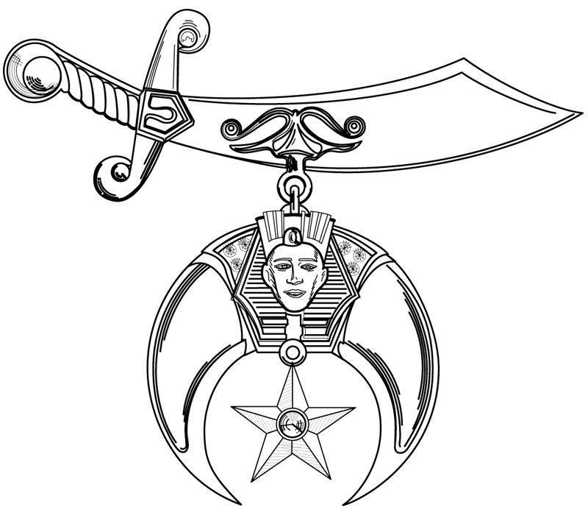
Sudan Shriners
Bylaws of

Uniformed Units

PREAMBLE:

The names of these Units shall be set out in Article I and said name is to be used only in connection with members of these Units while functioning or performing as an organized Unit of Sudan Shriners. NO UNIT OR ANY MEMBER THEREOF SHALL ENGAGE IN ANY ACTIVITY OR MAKE A PUBLIC APPEARANCE PURPORTED TO REPRESENT A UNIT OF SUDAN SHRINERS, UNLESS APPROVED BY THE POTENTATE.

No Unit shall have any additional Bylaws. It is the intent of these Articles to define uniform procedures and to supply the simple necessary administrative regulations to adequately meet the needs and requirements of the Uniformed Units of Sudan Shriners.

At the discretion of each Unit, the Unit may vote to adopt a separate set of Policy & Procedures consistent with special requirements of the Unit, when not in conflict with these Bylaws and submit in writing for the Potentate's approval.

ARTICLE I – UNIT NAMES, DESCRIPTION / PURPOSE

Section 1 - Names and purposes of Sudan Shriners Uniformed Units

1. Animated Animals - colorful entertainment of cartoon animal characters. (1976) Johnston Co.
- Beach Bums – colorful characters representing “beach” theme (1997) Dare Co.
- Burnouts – miniature barstools (May 2013) Craven Co.
- Camel Drivers - unit provides marketplace at Ceremonials to sell shrine jewelry & merchandise (1969) New Bern
- Cart Caravan – golf carts unit (2002) Lenoir County
- Carteret County Mariners - mini boat replicas of coastal fishing vessels (1990) Carteret Co.
- Chef Crew - trained staff prepares and serves the Ceremonial Moslem Feast (1957) New Bern
- Clowns - multifaceted unit that promotes merriment and laughter during parades and other select events (1952) Dunn
- Convertibles - provides transportation for the Potentate, Divan and other dignitaries in parades (1984) Kinston
- Cooligans – motorized coolers (May 2008) New Bern
- Cruisers – miniature race cars (Sept. 2010) Cumberland County
- Daredevils – specialized go-carts which perform vehicle ride over maneuvers (August 2004) South Brunswick
- Desert Rats – mini off-road vehicles with a “military” theme (1997) Greenville
- Drifters – motorized three wheel vehicles (Jan. 2015) New Bern
- Drum & Bugle Corps - a colorful marching / musical Unit (1923) Wilmington
- Fire Brigade - miniature fire trucks in parades (1980) New Bern
- Flag Unit - colorful flags representing all 50 states (1984) Dunn
- Hillbillies Clan 58 - Outhouse 2 - fellowship and entertainment with country "hillbilly" theme (Jan. 2009) Brunswick County
- Horse Patrol - live equestrian beauty and pageantry (1963) Wilson
- Keystone Kops – comical paddy wagon crew (1975) Jacksonville
- Mini Cars - antique miniature cars (1980) New Bern
- Mini-Rigs - miniature trucks for precision maneuvers in parades (1992) Wayne County
- Mobile Fez – to display the Shrine Fez in parades (1998) Pender County
- Monster Trucks – miniature trucks based on car crushing racing series (1997) Wilson Co.
- Motor Patrol - precision motorcycle drill team (1962) Kinston
- Mourners - unique funeral / mule drawn hearse (1979) Pamlico County
- Patrol - military drill team with precision marching (1917) New Bern
- Pirate Ship – mobile theme ship with colorful characters (1997) Fairmont
- Provost Guard - members police and secure events to maintain dignity and peace (1947) Greenville
- Prowlers – miniature go cart style cars for precision maneuvers (1997) Rocky Mount
- Racers - miniature race cars based on NASCAR Racing Series (1993) Harnett County
- Ritualistic Cast- Shrine Ritualistic Team that performs new candidates initiation ceremony (2016) Brunswick County
- Roadrunners - volunteer drivers transport children and families to SHC (1979) New Bern
- Roadsters - miniature antique classic cars for precision maneuvers (1991) Sampson Co.
- Scimitars – support temple initiatives (2014)
- Shriners Choo Choo - replica of vintage model train for parades (1988) Wilmington
- Steel Drum Band - calypso style musical entertainment (1977) Columbus County
- Thunderbolts - miniature cars for precision maneuvers (1975) Brunswick County
- Tomcats – miniature cars for precision maneuvers (1997) Robeson County
- Truckers - miniature trucks for precision maneuvers (1992) Pamlico / Craven County
- Van Patrol – miniature vans (Jan. 2012) – Onslow Co.
- Wrecking Crew - a trained staff for conducting new members thru 2nd Section Initiation (1925) Goldsboro

Section 2– Active Status

In order for a Unit to be considered active, they must participate during the year in at least three of the following mandatory Shrine events. By Imperial Law, this is at the discretion of the Potentate.
- Winter Ceremonial
- Spring Ceremonial
- Masonic Homecoming (Masonic Parade)
- SASA
- Fall Ceremonial

Section 3 - Dates and Times of Meetings

Dates and times of Unit meetings can be changed by majority vote of members at Annual Meeting. Potentate, Director and Recorder must be notified immediately of such change. Notice of special meetings must give the date, time, place and purposes of meeting. No business other than that for which meeting was called shall be transacted. Written notices shall not be required for regular meetings other than annual business meeting and annual election of officers. Twenty five percent (25%) of the active members shall constitute a quorum. Each Unit must hold a Stated Meeting at least once each calendar quarter.

Section 4 -Suggested Order of Business

- Roll Call
- Reading of minutes and communications
- Reading of applications and voting thereon
- Presentation of bills and voting thereon
- Reports of Officers
- Unfinished business
- New Business
- Good of Order
- Adjournment

Section 5 - Annual Meetings
The Annual Business Meeting of each Unit shall be its regular meeting in December. If Units hold weekly meetings, then the first meeting held in December shall constitute the Annual Meeting.

Section 6- Annual Election

The Annual Election of Unit Officers shall be held during the regular meeting in November or December, unless otherwise authorized by the Potentate. A written report naming the Elective and Appointive Officers shall be made to the Potentate by January 1, for his approval and appointment with a copy to the temple Recorder and Director. All Unit Officers approved by the Potentate shall be installed under his direction and at a time and place designated by him.

Section 7 – Unit Description

- Active Unit – A fully-functioning Unit is expected to participate in all official Sudan festivities, unless excused by the Potentate.
- Probation-Unit: A unit is placed on probational status due to non-participation in the minimum of three (3) shrine functions in a physical year. The unit may be restored to active status by complying with Section 2- Active status of the By-Laws of the Uniform Units of Sudan Shriners.
- Inactive Unit: A unit placed on inactive status due to non-participation in Sudan Shrine functions for a period of two (2) consecutive years. Once a unit is placed on the inactive status, all funds and property will be remitted to the temple office within 60 days. If a unit wishes to reactivate, a written request must be made to the Potentate. If approved, the unit will be placed on Apprentice Status.
- Apprentice Unit - a newly formed Unit that must serve a three (3) year probationary period prior to becoming an Active Unit.

ARTICLE II - OFFICERS, THEIR DUTIES, HOW ELECTED

Section 1 - Unit Officers

- Animated Animals Director
- Shriners Choo Choo Conductor
- Beach Bums Captain
- Burnouts Captain
- Camel Drivers Director
- Cart Caravan Captain
- Carteret Co. Mariners Captain
- Ritualistic Cast Director
- Chef Crew Director
- Clowns Director
- Convertibles Director
- Cooligans Big Kahuna
- Cruisers Crew Chief
- Daredevils Captain
- Desert Rats Captain
- Drifters Captain
- Drum & Bugle Corps Captain
- Fire Brigade Chief
- Flag Unit Director
- Gators Captain
- Ghostbusters Captain
- Hillbillies #2 Director
- Horse Patrol Captain
- Keystone Kops Chief
- Legion of Honor Commander
- Mini Cars Captain
- Mini-Rigs Captain
- Mobile Fez Director
- Monster Trucks Captain
- Motor Patrol Captain
- Mourners Director
- Patrol Captain
- Pirate Ship Captain
- Provost Guard Captain
- Prowlers Captain
- Racers Captain
- Roadrunners Director
- Roadsters Captain
- Steel Drum Band Director
- Thunderbolts Captain
- Tomcats Chief
- Truckers Captain
- Van Patrol Captain
- Wrecking Crew Director

. Section 1 - Unit Officers

- The Head of each Unit shall be elected by written ballot of a majority of the members of the Unit present and voting at the Annual Election (Article 1 Section 7). All other Unit Officers (Article II Section 1) shall be elected by written ballot of a majority of members of the Unit present and voting at the Annual Election.
- Unit Officers shall serve for the ensuing year. In the event of a vacancy in any office, it shall be filled by direction of the Potentate at a regular meeting by written ballot of a majority vote of the members present and voting and subject to the Potentate's approval and appointment.
- Each retiring Officer shall immediately pass on to his successor all records and/or equipment of the Unit in his care and/or custody. The Head of each Unit is charged with the responsibility for uniforms and equipment from retiring or dismissed members. It shall be the option of each Unit to require a deposit from its members for the issuance of uniforms with said deposit being refunded on the return of the uniform in good condition. Uniforms not returned shall be replaced at Unit expense.
- In addition to a Captain/Director/Commander/Chief, each Unit shall have a First Lieutenant/Assistant Director, a Secretary and a Treasurer. The Secretary and Treasurer must be separate positions. A Unit may have a Second Lieutenant if desired.

Section 2 - Unit Officers Duties

- Captain/Director/Commander or Chief shall be Executive Head of his Unit. He shall exercise general supervision over the Unit and shall preside at all meetings. He shall supervise the activities of his Unit Officers. He shall appoint committees necessary to fulfill the projects and program of Sudan Shriners and the purposes and functions of his Unit. He shall be directly responsible to the Potentate.
- First Lieutenants or Assistant Directors are second in command of their Units and in absence of their Unit heads shall be operating head of the Unit.
- Secretaries shall faithfully record the proceedings of all meeting. He shall collect all monies turning them over to the Treasurer. He shall keep on prescribed form the attendance for each member of his Unit. He shall maintain a current inventory of all the Unit property and all temple property entrusted to the care of his Unit. Inventory of temple property shall be on a standard form furnished by the Director of Units and in compliance with his instructions. He shall, at the Annual Election of Officers, turn in all records to his successor.
- Treasurer shall receive all monies from the Secretary. He shall keep a true account, recording all receipts and disbursements. He shall disburse such funds upon presentation of proper approval, this requiring a majority vote of the membership present and voting at a regular meeting. He shall, at the Annual Election of Unit Officers, turn all records over to his successor.

ARTICLE III - MEMBERSHIP

Section 1 - Application for Unit Membership

(a) Subsequent to a report on a candidate’s petition, paper ballots shall be distributed, marked, collected and counted in the presence of the membership. If a majority of the ballots are favorable, the candidate is elected to unit membership. If a majority of the ballots are unfavorable or if the votes are evenly divided, the candidate is rejected. The presiding officer may call for a collective vote.
(b) Written Objection. A written objective, signed by at least 3 members of the unit in good standing, presented to the Director of the unit or Secretary prior to the time of balloting is commenced, has the same effect as an adverse ballot.
(c) Written Objection Deadline. Any written objection must be received by the Unit Director or Secretary at least 48 hours before the time specified in the notice for balloting.
(d) After the balloting is completed and the candidate is declared elected and notified, no objection made thereafter with respect to the candidate maybe considered unless ordered by the Potentate.
(e) Reapplication: A rejected Candidate may reapply in 90 days.

Section 2 - Active Members

Shall consist of these Nobles who have been elected to this status, by the active members present and voting by secret ballot. Active members shall be elected from those members who have been on the Apprentice rolls for six (6) months or longer. All Unit officials shall be elected by secret ballot from this classification.

Section 3 - Apprentice Membership

Shall consist of those Nobles who have been elected to this status, by active members present and voting by secret ballot. Apprentice members shall pay dues, if Unit policy, but shall not have the right to vote: however, Apprentice members shall have the right to vote after one year of active service in the Unit, and shall serve the Unit in that status for a minimum of six calendar months from the date of a favorable vote of his application of membership.

Section 4 - Associate Members

Shall consist of those members who have attained at least one (1) year of Unit service and who request their Unit in writing for this classification. Election to this classification requires a majority vote of the “active” members present at a regular meeting of the Unit. Associate members shall pay dues, but shall not have the right to vote.

Section 5 - Emeritus Members

Shall consist of those Unit members who have served as Potentate of Sudan Shriners or have attained a minimum of twenty (20) years of Unit service and who request their Unit in writing for this classification. Emeritus members are relieved from paying dues and are not subject to attendance requirements. They have all rights and privileges of an active member.

Section 6 - Honorary Members

Shall consist of those Nobles elected to this status by the Unit. Such membership confers no rights or privileges.

Section 7 – Dues

Sudan Shriners current year membership dues must be remitted to the temple office prior to the January Ceremonial as a condition for continuing Unit membership. Unit dues for members will be at the option of the Unit. Additionally, the Unit Head must physically check his member’s temple dues, as well as their Blue Lodge Membership and submit written confirmation to the Shrine office by January 15th to ensure compliance.

ARTICLE IV - DISCIPLINE

Section 1 - How investigated

The head of the Unit is empowered and obligated to temporarily suspend any member who, in his judgment, is guilty of conduct unbecoming a noble. He shall then file written charges with the temple Director, with copies to the Potentate and Recorder. Any member may file charges against another Unit member, if in his judgment, there are grounds for such charges and if the Unit Head refuses to take action. The charges must be filed in writing with the temple Director, with copies to the Potentate and Recorder.

Section 2 - Procedure

Upon receipt of such charges, the temple Director shall thoroughly investigate them. If in the judgment of the Director that an offense has been committed, he shall within five (5) days make a written report to the Potentate, who shall take action as he deems appropriate.

Section 3 - Appeal

An appeal of any disciplinary action may be made only to the Potentate, and only then by the member, or members, directly involved. Said appeal must be in writing.

Section 4 – Restoration

Upon termination of membership, regardless of the reason, the noble desiring to re-affiliate with his Unit, shall apply and shall comply with the provisions of Article III, as if he had never belonged to a Unit.

Section 5 - Offenses and Penalties

Any member who is guilty of conduct unbecoming a Shriner or who is guilty of conduct unbecoming a Mason, as defined in the Masonic manual and Code published by the Grand Lodge of North Carolina, or who shall fail to perform duties assigned to him by the head of his Unit and/or the temple Director, or who shall be guilty of improper performance of his assigned duties, shall be subject to reprimand, suspension or dismissal.

- ANY MEMBER INDULGING IN THE USE OF INTOXICATING, ALCOHOLIC BEVERAGES, DURING ANY PARADE, CEREMONIAL, SHRINE OR SHRINE SPONSORED EVENT, ON DUTY, SHALL BE SUBJECT TO REPRIMAND, SUSPENSION OR DISMISSAL.
- Any member who attends any business meeting of his Unit while under the influence of intoxicating beverages shall be subject to reprimand, suspension or dismissal.

ARTICLE V - AWARDS, AUDITS, AMENDMENTS AND EQUIPMENT

Section 1 - Awards

An incentive awards program may be adopted to give recognition for outstanding achievements, should the Unit wish to do so.

Section 2 - Audits

In November of each year, a STATEMENTS OF CASH RECEIPTS AND DISBURSEMENTS form prepared by the temple Auditor will be mailed to each Unit to be completed and returned to the Temple office - no later than February 28th. All unit activities, meetings, parades, etc. are automatically suspended after the due date. This is an urgent matter and the Unit Officers must give it special attention. The Auditor must have this information from every Unit in order to prepare the Internal Revenue Form 990 for Sudan Shriners, which includes all of the Units. This is a requirement of the Internal Revenue Service and all Units must be on one Tax Return filed from the temple office, which makes it necessary that the above information be sent to the temple office for the accountant to prepare the Tax Return. The information requested on the forms is a requirement of the Internal Revenue Service and information must be complete before they will accept the Tax Return. Full cooperation will be appreciated, as it is quite a tremendous job to compile all tax information required by the IRS. Failure to comply could result in a penalty and fine against the Officers of the Unit as well as the temple, plus a possibility of losing present tax status.

Section 3 - Amendments

These Bylaws cannot be amended except by the authority of the Potentate.

Section 4 – Equipment

All parade vehicles and / or performance equipment belonging to a Unit or its individual members should be checked bi-annually for “Safety Inspections”. This inspection is to ensure that whatever a member is holding, carrying, driving or operating is in good working condition. The Unit head or appointee would be responsible for documenting and filing the inspection with the Shrine office.

Section 5 - Power of Potentate

Nothing herein contained shall abridge or limit the power of the Potentate and, at his discretion, he may suspend the Bylaws in whole, or in part, for such time and for such purposes as the nature of the circumstances may warrant.

Approved this 14th day of July, 2011

Authority of: ___________________________________ Dated: __________________________
Unit Director / Captain
_____Frank Long__________________
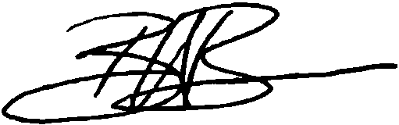
Director of Units

___________________________________
Potentate

Amended 11/17/00
Amended 9/13/01

Revised 3/18/02

Revised 1/27/07
Revised 7/14/11
Revised 11/15/18

