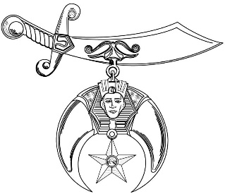
Sudan Shriners
Fall Ceremonial
November 20 – 21, 2020
Dunn, NC

Thursday, November 19, 2020
5:00 pm Board of Directors Meeting – Dunn Shrine Center – 211 N. Clinton Ave.

Friday, November 20, 2020
10:00 am Golf Tournament – Chicora Country Club – 495 Chicora Dr., Dunn, NC
11:00 am - 3:00 pm Open for Lunch, Shopping, & Sightseeing
4:00 pm – 11:00 pm Casual Friday Hospitality and Entertainment – Chicora Country Club
Music by “Jones Pro Sound”

(Admission by 2020 Shrine or Blue Lodge Dues Card – Dress: Casual)

Saturday, November 21, 2020
7:30 am Registration of Candidates, Candidates Orientation – Dunn Middle School - 1301 Meadowlark Rd.
8:00 am Stated Business Meeting – Dunn Middle School
9:00 – 11:00 am Ladies Breakfast & Entertainment – Dunn Shrine Center
(All Ladies and Candidate Wives welcome)
9:30 am First Section – Shrine Degree by Ceremonial Cast – Dunn Middle School
10:30 am Parade Formation – N General Lee Ave. & W Harnett St.
11:30 am Parade Steps Off – W Broad & N General Lee
12:30 pm Moslem Feast – Dunn Middle School
1:30 pm Second Section – Dunn Middle School Gymnasium
3:00 pm - 5:00 pm Shrine Headquarters Hospitality Room – Hampton Inn
7:30 pm – 9:00 pm Introduction of New Nobles - Rose and Fez Presentations, Memorial Service, Hospital Patients Introductions, Check and Awards presentations.
Dunn Shrine Center
9:00 pm - 12:00 am Potentate’s Dance – Music by “Bounce Band”

Admission by 2020 Shrine Dues card

Dress – Nobles Coat / Tie – Ladies - Dress or Pantsuit
Fezzes Requested

Shuttle Service will be provided to and from area hotels to the dance.

“Having Fun – Helping Many in 2020”

