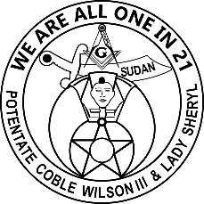
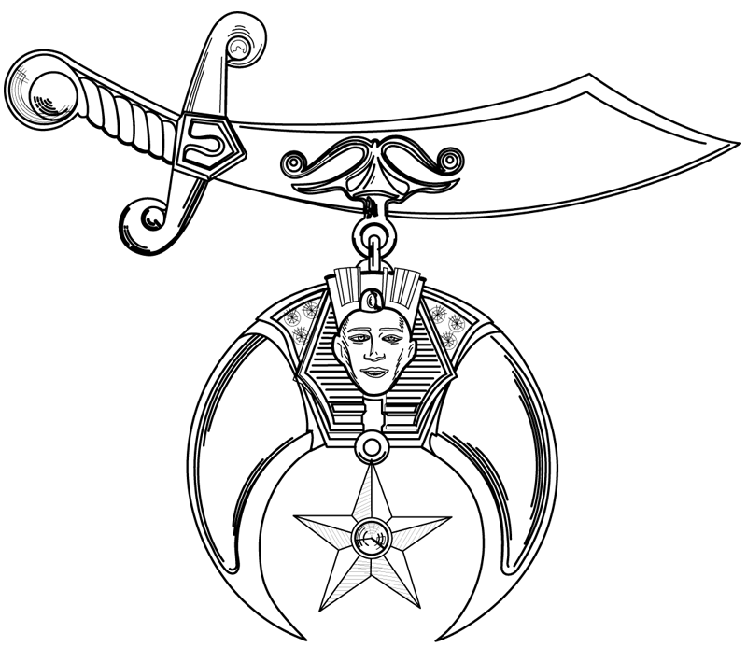
SUDAN SHRINERS

Fall Ceremonial ~ Lumberton, NC

Schedule of Events
November 18 – 20, 2021

Thursday, November 18, 2021

4:00 pm Board of Directors Meeting ~ Robeson County Shrine Club, 2250 McPhail Rd., Lumberton

Friday, November 19, 2021

8:30 am Cabiri Breakfast – Location TBD
11:00 am Golf Tournament - Fairmont
11:00 am ~ 5:00 pm Open for Lunch, Shopping & Sightseeing
5:00 ~ 10:00 pm Food, Fun, Fellowship & Music by DJ
Southeastern Agricultural Center - 1027 U.S. Highway 74 East

Admission by 2021 Blue Lodge or Shrine Dues Card

Casual Dress
Complimentary Shuttle Service Available

Saturday, November 20, 2021

7:30 am Candidates Registration, Fez Sizing, Medical Review & New Candidate Orientation
Lumberton High School - 3901 Fayetteville Road
8:30 am Stated Business Meeting ~ Lumberton High School - Auditorium
8:30 am Ladies Breakfast & Entertainment ~ Adelio’s ~ 111 W 3rd St. (Ticketed Event)
(All Ladies & Candidates Wives Welcome)
9:00 am First Section ~ Shrine Degree by Ritualistic Cast ~ Lumberton High School - Gymnasium
10:00 am Parade Line Up – Step off Approximately 11:00 am, following Lumberton Christmas Parade (steps off at 9:30) - N. Elm Street & disbands on W. 31st Street
12:00 pm Moslem Feast - Lumberton High School / Cafeteria
1:30 pm ~ 3:30 pm Second Section ~ Lumberton High School / Gymnasium ~ Wrecking Crew
3:00 pm ~ 5:00 pm Open for Supper, Shopping & Sightseeing
7:00 pm ~ 7:30 pm Hors d'oeuvres & Refreshments – Southeastern Agricultural Center
7:30 pm ~ 9:00 pm Fez & Rose Presentation, Patient Introductions, Check Presentations, Drawings & Potentate Remarks ~ Southeastern Agricultural Center
9:00 pm ~ 12:00 pm Potentate’s Dance – “Spare Change”

Nobles / Ladies & Invited Guests Only
BYOB & Setups and Beer Available

Coat and Tie

Fezzes Requested for all Activities
Complimentary Shuttle Service Available

“We are All One in 21”

